|  |  |  |
| --- | --- | --- |
|  | Scrapers GUI  Documentation |  |

Introduction

This program monitors and manages web-scrapers. With the advantage of the easy-to-use GUI, you can list your scrapers in the program and schedule run them, monitor when they last ran and more!

Usage

Installation

1. Copy the .exe file to a new folder and run the file.

* When the program first starts, it creates a `settings.json` file where program settings and all scrapers are stored.
* Moving the .exe file to another folder or deleting the settings file leaders to losing the scrapers listed on the program and previous settings.

Or:

1. Execute the python code from the terminal using the command:

`python scraper_gui.py`

Make sure to install the required libraries before executing the code, run the following command to install them: `pip install -r requirements.txt`

Adding New Scraper

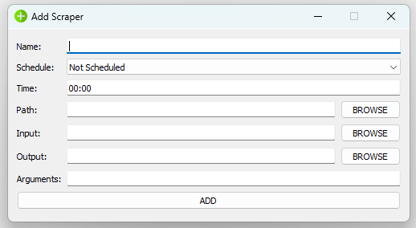

**Fields**:

* Name: Name used in the program to call the scraper, can be any name.
* Schedule: How often the scraper runs (Hourly, every 4 hours or daily).
* Time: Works for “daily” scheduled scrapers only. Sets a time at which the scraper runs every day.
* Path: Where the scraper python code is located.
* Input: Location of input file.
* Output: Location of output file.
* Arguments: Any additional data passed to the scraper.

Finally, the command that the scraper calls is generated as follows:

python <Path> <input> <output> <arguments>

Removing Scraper

Select the scraper from the list and press DELETE button.

Pre-Requisites:

Input path, Output path, and arguments are passed to the scraper code and are read using the following code:

import sys

input_file = sys.argv[1]

output_file = sys.argv[2]

arguments = sys.argv[3]

An example of the previous code:

import sys

input_file = sys.argv[1]

output_file = sys.argv[2]

with open(input_file, 'w+') as file:

    file.write('This line is written to the input file')

Program Settings:

Settings file is JSON, it is easy to modify when necessary (but remember to take a copy because wrong JSON format results in erasing all the data).

{

    "scrapers": [

        {

            "name": "Test Script",

            "path": "D:/Tim_projects/Scraper_GUI/output/scrapers/script.py",

            "cmd": "python D:/Tim_projects/Scraper_GUI/output/scrapers/script.py",

            "schedule": "Hourly",

            "time": "00:00",

            "lastRun": "16-03-2022 06:21",

            "status": 0

        }

    ]

}